Frequently Asked Questions
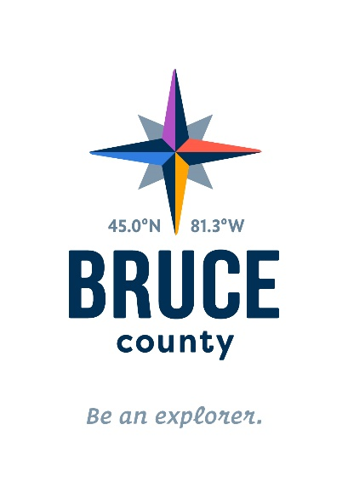
- What is our brand story?

Be an Explorer- The Story

We are the explorers. The dreamers who take roads less travelled. Those who turn alternatives into sustainable choices. Those who see tried and true as an invitation to try something new. Here’s to children who look under rocks. And parents who help with the lifting. Here’s to active, inquiring minds, and those with the vision to look beyond obstacles. Here’s to celebrating business innovation – and just as important, to exploring farm life in the morning, beach life in the afternoon and bright starry skies all night long. Here’s to the explorers – here’s to us. Bruce County is where those roads less travelled become a journey: In life, in our work, in our communities, and in how we spend our days together.

- Where do I find information on how to use the brand elements?
The “You are Bruce” Brand guide is a full explanation of the new brand including the vision, the language, the elements and how to use them. The guide explains the messaging, the process and how to use the elements. It also demonstrates the personality for the interpretation. This voice is the most important aspect of the guide to live and breathe. It requires support and nurturing as it will take time to fully integrate. You are all guides in this journey.

- Why the star?
  - The star is a classic symbol of exploration and has been such for millennia. It reflects our night skies and guides the journey regardless of where you are in Bruce or what your journey entails. In that way, it reflects tourism, business and community equally well.
  - The star works as both a symbolic graphic and as a crest. It feels both organic and corporate. It's slightly horizontal feel allows closer proximity to the rest of the elements.
  - The shape is 3-dimensional, to match the three primary attributes of the County (energy, environment and agriculture). It also still looks and feels like a star even though it has evolved from the literal versions.

- Why these colors?
  - The palette is sky inspired and blends well with sub-brands.
  - The palette is unique when compared to neighboring counties and place brands.

- Why are we using this new font and how does all of these things tie together?
  - The font and the font colour are the rock - the foundation upon which we build everything else.
  - The icon (star) nestles close to the foundation and the latitude/longitude identify the place – not to be taken literally.
  - The numbers invite exploration. The lower case on the word 'county' makes the corporate or government side of the brand I.D. more approachable and personable.
  - Everything pulled together exemplifies both strength and approachability.

- How do I implement the Explorer Brand messaging?
  - This voice is the most important aspect of the Be an Explorer brand. Framing that voice and beginning to use it to define our internal culture is an important first step. The voice, language, and culture require all of our support and nurturing for it to fully integrate and this will take time. You are all guides in this journey.
  - The icon and templates are designed in a specific way to help support our brand vision. Page 36 of the “You Are Bruce” guide lists some possible words to use when you are writing and it makes sense to use “Bruce Talk”.
  - On page 37 you’ll find a brand checklist which will also help you make decisions when using the brand.

- What if I need help with using the brand or one of the templates? Is there someone I can ask?
  - The “Brand Implementation Team” members are here to help. They are Carolyn Thibaudeau from Highways, Krys Walter from Social Services, Rick Aitken and Paul McGrath from IT, Janice Mewhinney from the Museum and Jill Roote from Planning and Development.
  - Team members can assist Departments with questions related to integration of the language, elements usage and templates. It is important that if there are questions regarding implementing the brand that people utilize the knowledge of the cross functional team so we make sure that the evolution goes as smoothly as possible.

- How will the Brand be implemented? The initial brand roll out will take place over the next three years. Here is how it will look.
  - Year 1 – The slow, silent launch – Internal building of the Explorer culture
  - Year 2 – The Bridge – Externally including touchpoints with highest impact
  - Year 3 – Sustain - deliberate process for annual review and continuous improvement

