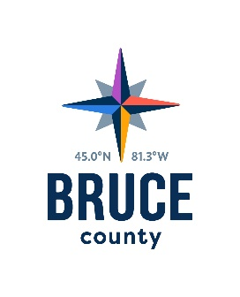
  - Paramedic Services Committee Minutes

November 1, 2018

11:28 a.m.

Council Chambers, Bruce County Administration Centre

Walkerton, Ontario

Present: Warden Paul Eagleson,
Councillors Robert Buckle (Chair), Anne Eadie, David Inglis, Janice Jackson, Mike Smith, Milt McIver and Mitch Twolan

Staff: Kelley Coulter, Chief Administrative Officer
Darlene Batte, Deputy Clerk
Nicole Charles, Director of Library Services
Christine MacDonald, Director of Human Services
Cathy McGirr, Director of Museum
Michael McKeage, Director of Health Services
Kara Van Myall, Director of Planning and Development
Donna Van Wyck, Clerk

Pecuniary Interest
There were no declarations of pecuniary interest.

Information Items
The Inter-facility Transfer Call Volumes Report was received for information.

Act on Recommendations
Moved by Councillor Janice Jackson
Seconded by Councillor Mitch Twolan

That in accordance with the Procedure By-law, staff be authorized and directed to give effect to the actions of the Paramedic Services Committee in respect of all resolutions passed during the November 1, 2018 meeting.

Carried

Next Meeting
The next meeting of the Paramedic Services Committee will take place on December 6, 2018 in the Council Chambers, County Administration Centre, Walkerton, Ontario.

Adjournment

Moved by Councillor Mitch Twolan

Seconded by Councillor Milt McIver

That the meeting of the Paramedic Services Committee adjourn at
11:37 a.m.

Carried

Councillor Robert Buckle, Chair
Paramedic Services Committee

