Grandfriends Graduation
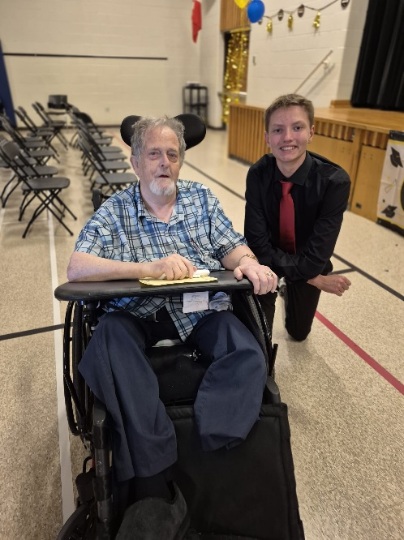
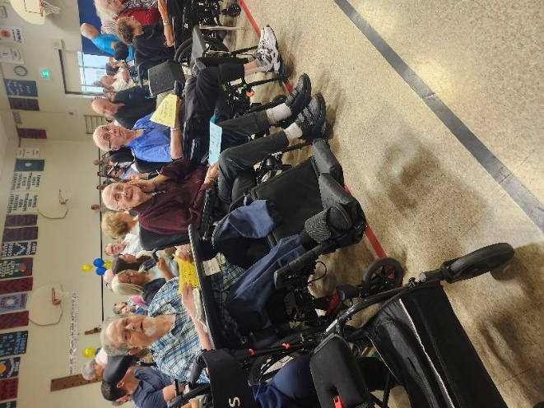
On June 23rd our Grandfriends attended the Grade 8 Graduation at Mildmay-Carrick Elementary School. Residents involved in this annual program have been fostering relationships with their matched student all school year, and now to top it off – we got to watch them walk across the stage at their Graduation Ceremony! A big thank you to Tammy & Stephanie, the teachers from Mildmay-Carrick who, for the past three school years, have organized and coordinated with our recreation team for another successful Grandfriends partnership.

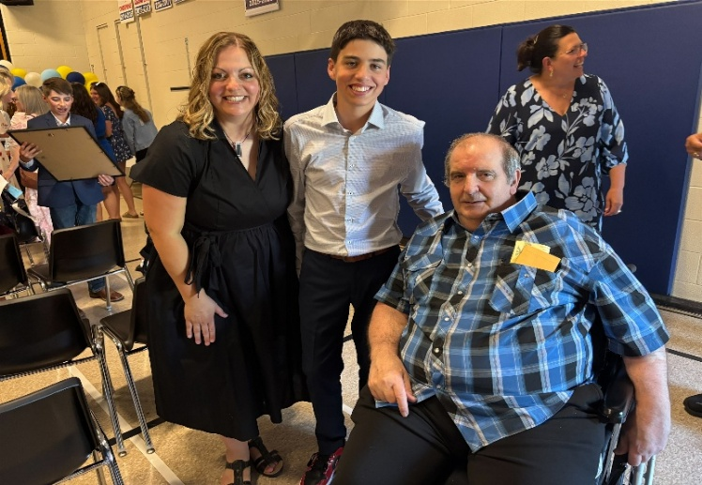
Congratulations Class of 2026!
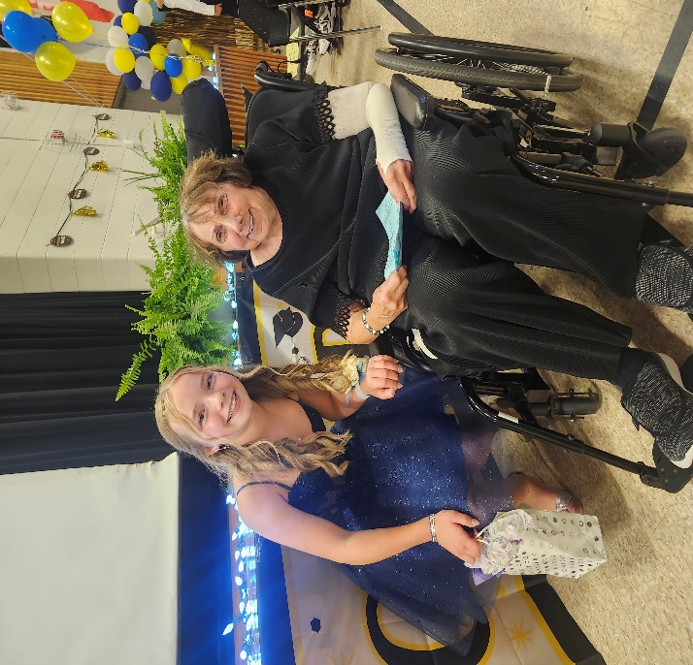
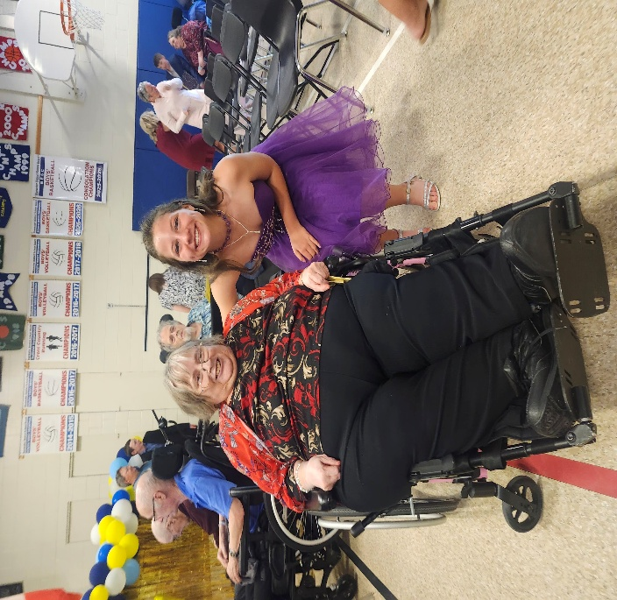
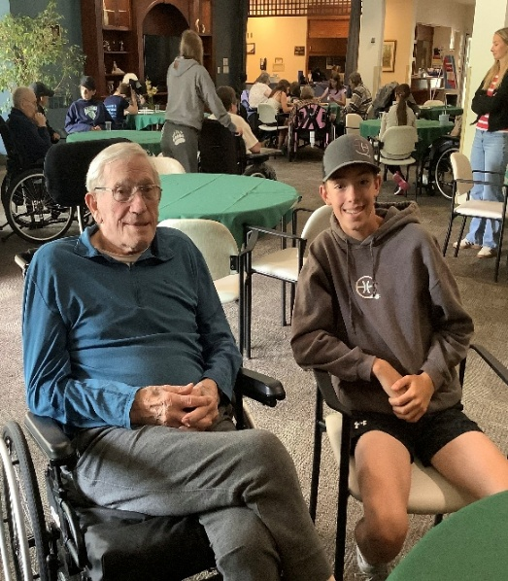
Grandfriends Final Visit
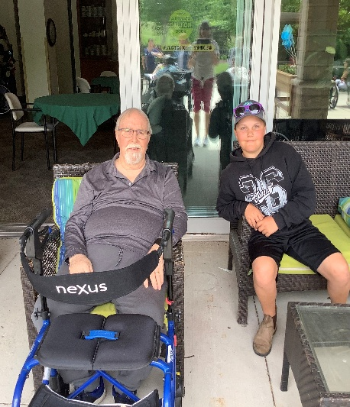
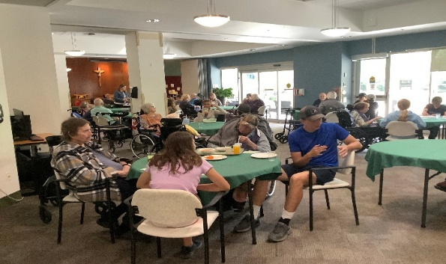
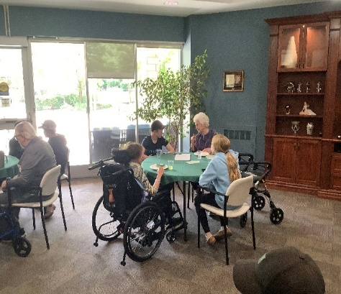
Our Grade 8 Grandfriends from Mildmay- Carrick Public School joined us for one last visit at Brucelea Haven on June 15th. We had a pizza lunch along with chats, diamond art, and strolls in our garden to finish off our last visit to end the school year. We are so thankful for another amazing year of building great connections and relationships with another special group of students from Mildmay-Carrick. Thanks again to their teachers in helping to facilitate such an amazing program!

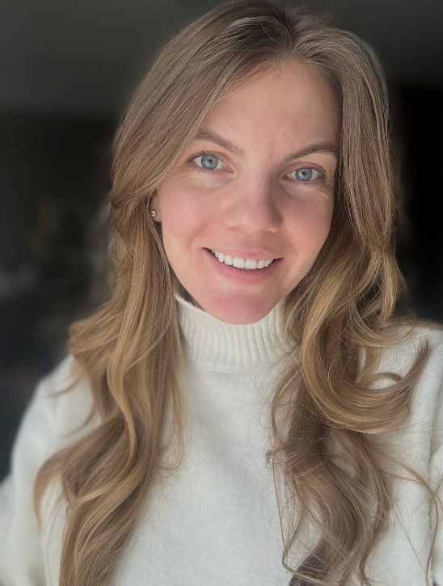
Welcome Emily MacDonald – Recreation & Leisure Manager!
We are pleased to announce that Emily MacDonald has accepted the position of Recreation & Leisure Manager at Brucelea Haven. With her several years of valuable experience as an RPN and a background of Recreation & Leisure Manager, she will be a wonderful asset to our home! Emily will be joining our leadership team on July 8! Please join us in extending a warm welcome to Emily as she transitions into this exciting opportunity!

Welcome Joan Docto – PSW Student
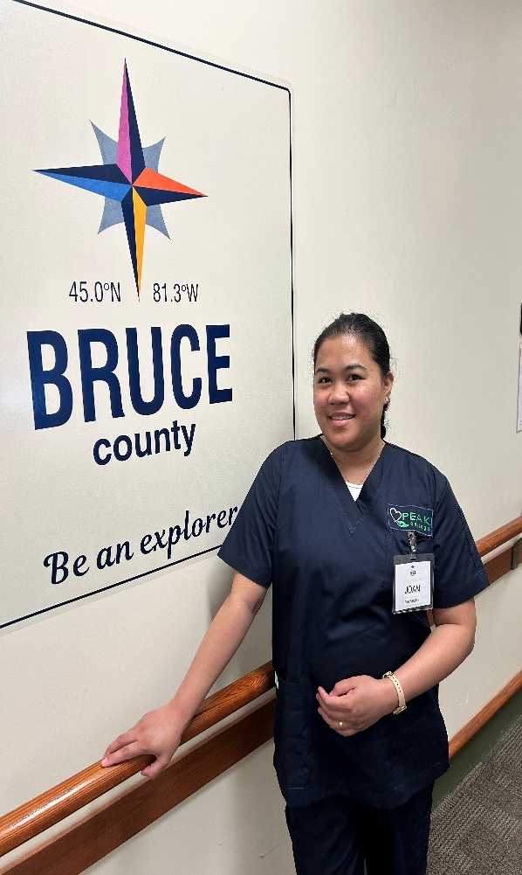
My name is Joan Docto, and I am originally from the Philippines. Before deciding to pursue the PSW program, I had experience caring for family members, which inspired me to enter the healthcare field. Back home, I also saw how passionate my mother was about helping people in our community and how tirelessly she worked in the hospital and healthcare centre. Seeing her dedication inspired me even more to pursue a career in healthcare. In addition, seeing my husband now working in a healthcare facility and witnessing how compassionate, dedicated, and hardworking he is has motivated me even further to become part of the healthcare profession. Because of their influence, I became more eager and inspired to work in healthcare and make a positive difference in the lives of others.
I chose to become a Personal Support Worker because I am passionate about helping others, providing compassionate care, and supporting individuals with dignity and respect.
Through my clinical placement at Brucelea Haven, I hope to gain valuable hands-on experience, improve my caregiving skills, and learn from experienced healthcare professionals. I am looking forward to building meaningful connections with residents and becoming part of a supportive healthcare team. I would also like to sincerely thank Vanessa Wheeler and Sue Page for their guidance and support throughout my placement. I truly appreciate this opportunity and look forward to learning from everyone at Brucelea Haven

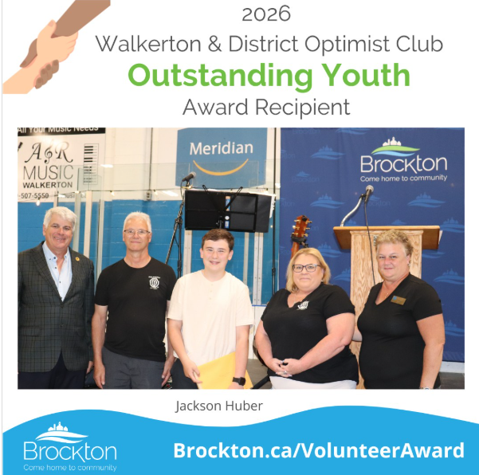
Congratulations Jackson Huber!
Congratulations to Jackson Huber on receiving the 2026 Outstanding Youth Award for his volunteer time at Brucelea Haven. Jackson is celebrated for his avid involvement supporting programming with seniors and spending valuable time with each resident, whether it be after school, throughout the summer or while dressed up as the Easter Bunny! Thank you Jackson for your time and dedication to making our residents smile. It is much appreciated!

We would like to thank all of our volunteers for their contributions to Brucelea Haven, we could not do what we do without your help and dedication to our residents!

If you are interested in volunteering, please come to the home and fill out an application form! We would love to have you join our Team!

Spring Vendor Market
A Successful First Spring Vendor Market!
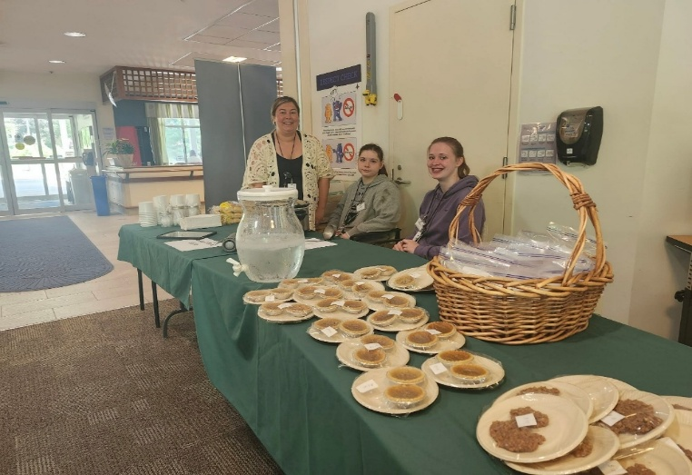

Residents, families, and community members enjoyed browsing the Spring Vendor Market held at BLH on June 11th. Vendors offered a wide variety of items, including wreaths, Tupperware, hand towels, fudge, and many other unique goods. Residents also played an active role in the event, preparing a selection of baked goods for the Resident Council table, as well as offering soup and biscuits for sale. All proceeds from the market supported the BLH Resident Council Fund. Thank you to everyone who came out and helped make our first Spring Market an enjoyable event!
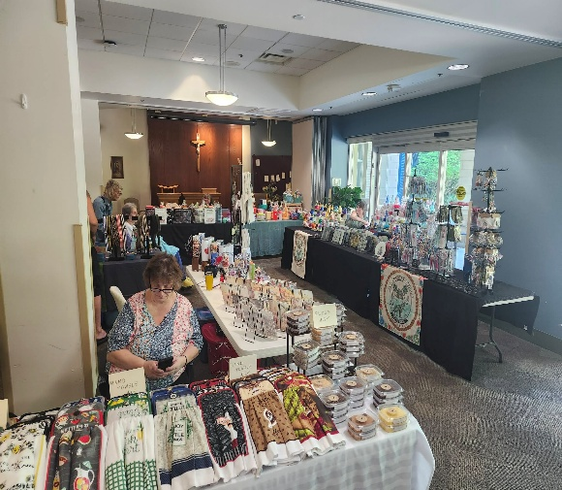

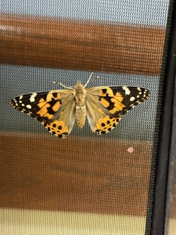
Butterfly Hatching
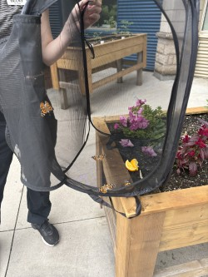
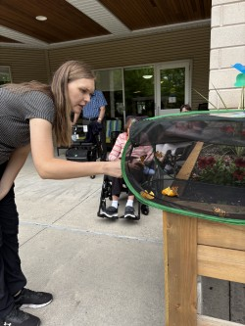
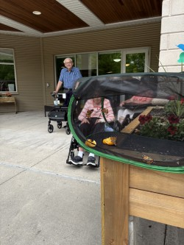
Earlier this month the BLH recreation department had a very special delivery in the form of Painted Lady caterpillars! Friday June 26th the butterflies from 2nd floor and 3rd floor were eager to be released. There were about 15 butterflies released into the Central garden while residents watched on. The butterflies life cycle is expected to be about 2-4 weeks in the wild.
Bus Trip to Gails Farm
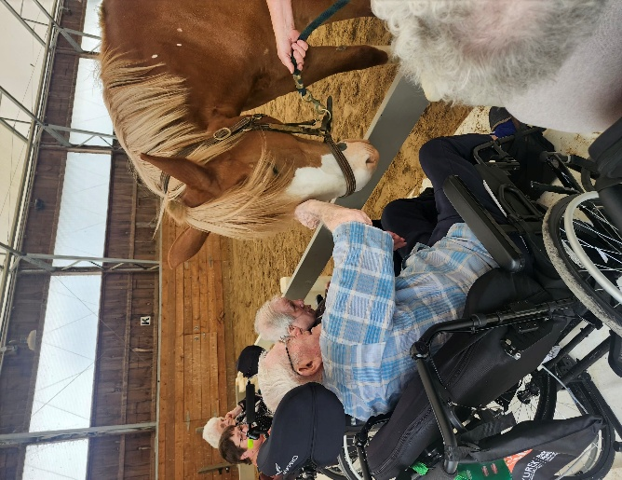
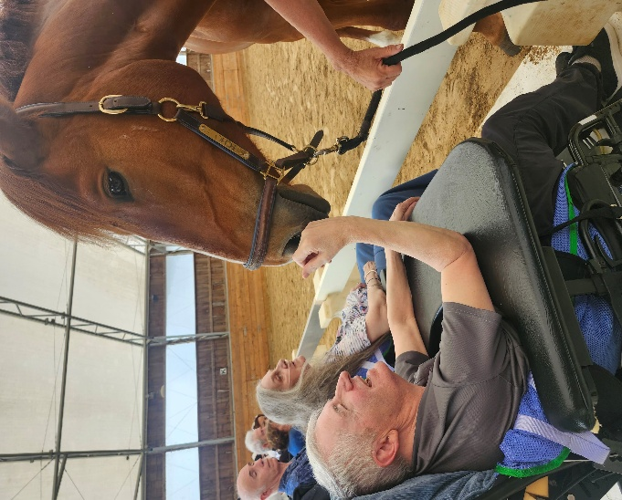
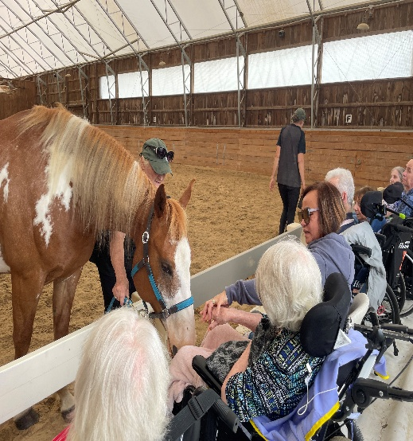
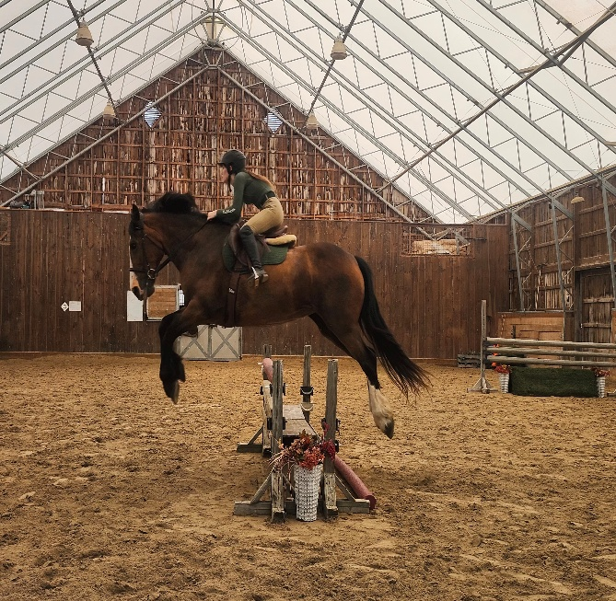
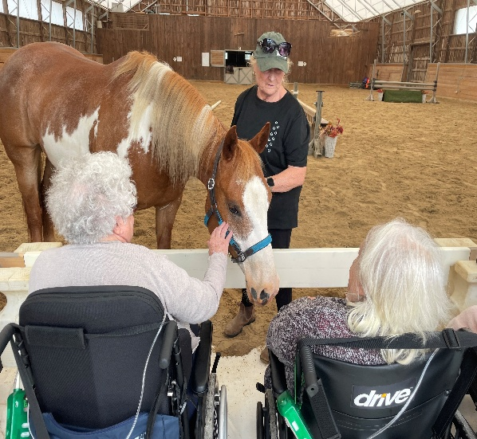
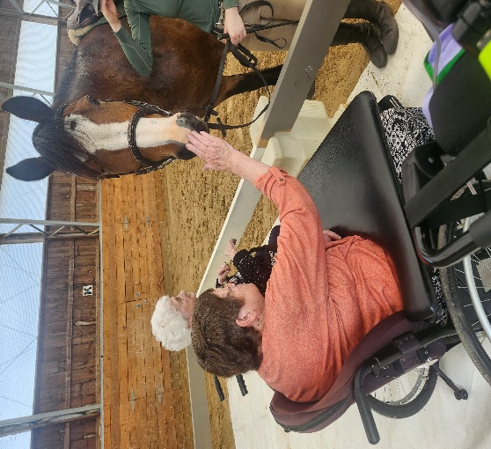
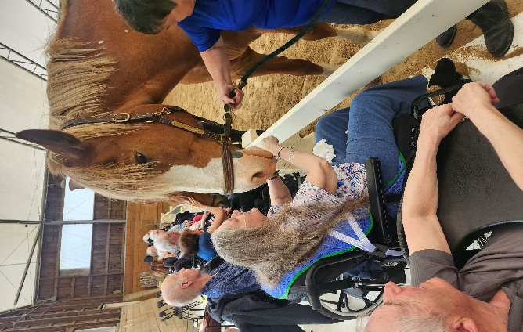
Residents enjoyed a delightful outing to River Ridge, the horse farm owned by Gail Pletch, on June 9th, where a special horse show was held just for them! The talented horses and their riders entertained the group with a variety of jumps and obstacles on the ground, creating an exciting and engaging performance. Adding to the charm, the horses even moved in rhythm to the music. Residents also had the chance to meet and interact with the horses up close! It was a memorable and enjoyable experience for everyone who attended.
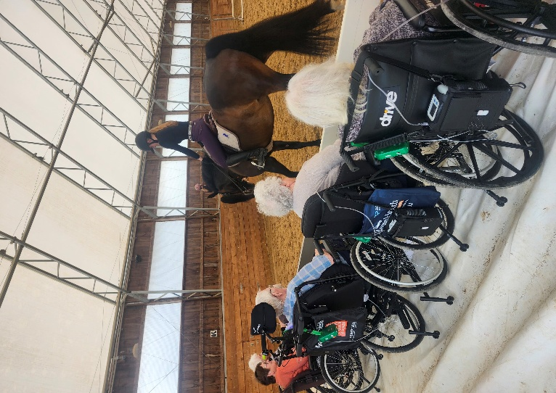
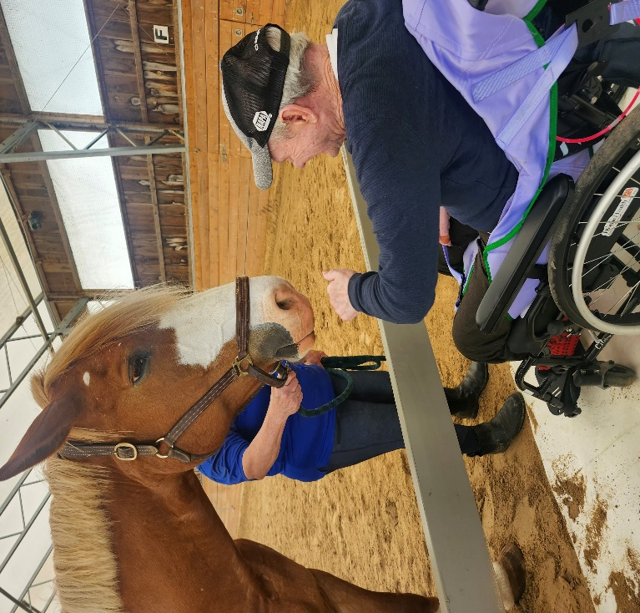
Pine River Horse Farm continued….
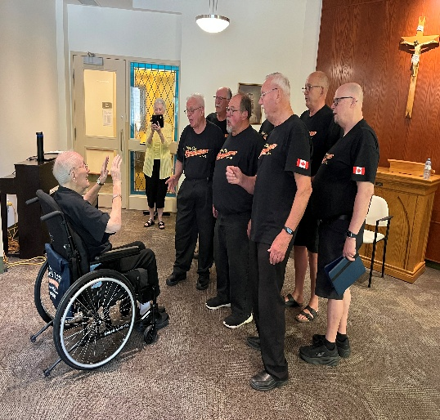

Barbershop Octet Group Performs
David Littwiller conducting the twin city harmonizers, a group he was a part of for 20+ years! The octet even surprised him with a matching t-shirt!


Monthly Caregiver Support Group for Family & Friends of Brucelea Haven
Brucelea Haven is excited to host monthly caregiver support groups on the last Thursday of each month from 2-3pm in the Conference Room, with Lauren Kieswetter, MSW. You are welcome to attend this group if you are someone who loves and cares for a resident residing at Brucelea Haven.
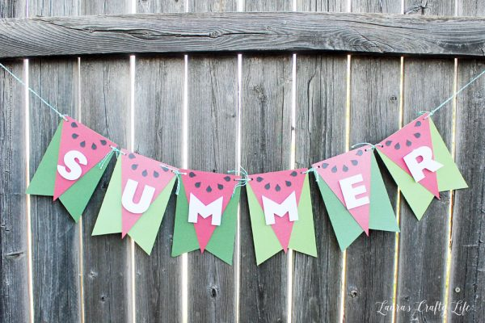

Upcoming Family Town Hall
Our next Family Town Hall meeting will be hosted on July 14th at 4pm in the CAA. During this meeting we will provide a review of the Residents Bill of Rights and a day in the life of a resident.
A large focus of 2026 is changing the language we use in LTC to Person-Centred Language. We invite everyone, family members as well, to take part in the e-course found through the CLRI to further enhance their own understanding of person-centred language. Implementing Person-centred Language: An Overview for Long-Term Care Team Members - Ontario Centres for Learning, Research, and Innovation in Long-Term Care

A Message from IPAC Lead – Jena March
Brucelea Haven experienced no new outbreaks during the month of June, and while 3 South remains in outbreak status, there have been no new resident cases identified. We are hopeful that the outbreak can be declared over by mid-July. On June 10, residents received their COVID-19 booster, with 65% choosing to be vaccinated. Thank you to our residents, families, and staff for their continued support in helping to keep our home healthy and safe.

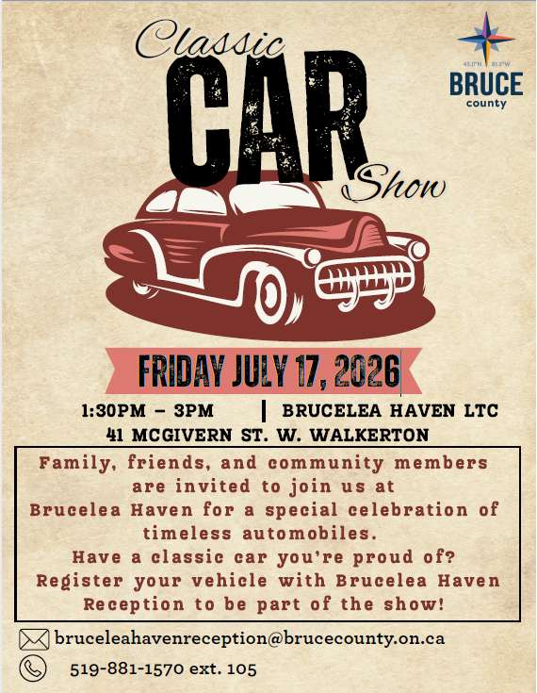


Special Events in July…
1st Canada Day Show with Joe Passion 2pm CAA
3rd July Resident Council Meeting 2pm in CAA
7th Music with Helen Stewart 2pm CAA
10th Bus Trip: Fishing at Lang's Puddle 9am-12pm
10th Bus Trip: Afternoon Drive & Ice Cream 1-3:30pm
15th Bus Trip: Dell's Diner in Clifford for Lunch 10am-3pm
16th Music with Brent Meidinger 10am CAA
17th Classic Car Show 1:30-3pm in the Front Parking Lot
17th Music with Ray Richards 2pm on 2S
21st Music with PJ Mack & Glow Party 2pm CAA
29th Music with Al Crawford 2pm CAA
July 30th – August 3rd – Walkerton Homecoming!

